**Pre GCSE Chemistry**

**Core Principles and ideas to learn prior to course delivery.**

|  |  |  |  |
| --- | --- | --- | --- |
| **Focus** | **Complete** | **Confidence** | **To improve I need to…..** |
| **1** |  | **\* * \*** |  |
| **2** |  | **\* * \*** |  |
| **3** |  | **\* * \*** |  |
| **4** |  | **\* * \*** |  |
| **5** |  | **\* * \*** |  |
| **6** |  | **\* * \*** |  |

Focus 1 Atomic Structure

**Need help? Visit:**

<https://tinyurl.com/6wyyw5d>

**Or use the QR code adjacent.**

Complete the tables:

|  |  |  |  |
| --- | --- | --- | --- |
| Subatomic particle | Relative charge | Relative mass | Location |
| Proton |  |  |  |
| Neutron |  |  |  |
| Electron |  |  |  |

|  |  |  |  |
| --- | --- | --- | --- |
| **Atom** | **P** | **N** | **E** |
| Na |  |  |  |
| Rh |  |  |  |
| phosphorus |  |  |  |
| The last element in group 7 |  |  |  |
| Xe |  |  |  |
| The only liquid non-metal |  |  |  |
| Carbon-14 (14C) |  |  |  |

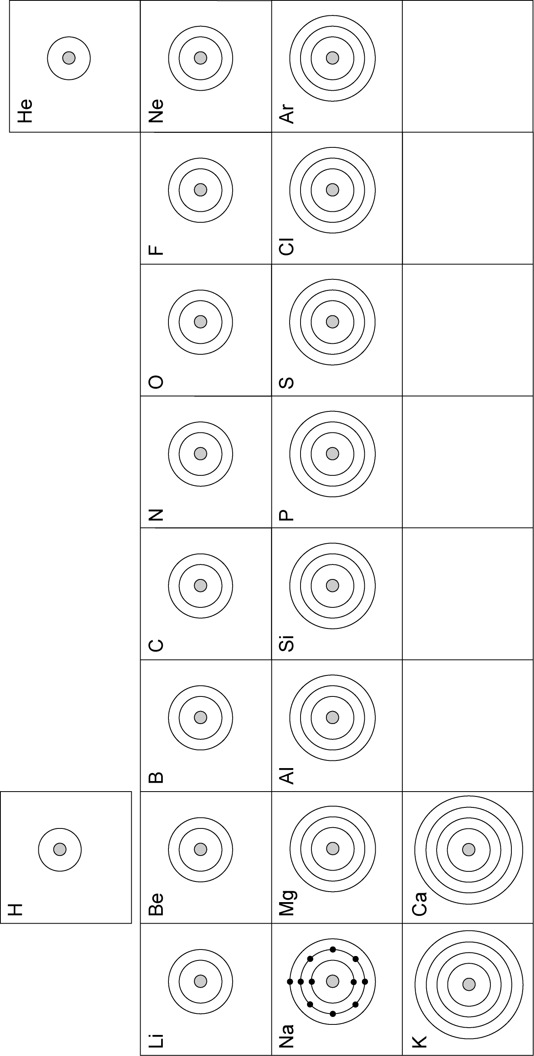Focus 2: Electron Configuration.

A close up of text on a black surface

Description generated with high confidenceComplete the shells. Remember 2,8,8.

**Need help? Visit:**

<https://tinyurl.com/electronshells>

**Or use the QR code below.**

Focus 3- Relative formula mass

**Need help? Visit:**

<https://tinyurl.com/relativeformulamass>

**Or use the QR code below.**

Elements have an atomic mass. Compounds have a formula mass.

A picture containing indoor, crossword puzzle, text

Description generated with high confidenceTo find the relative formula mass of a compound, add together the relative atomic masses of the elements in that compound.

For example,

The relative formula mass of Magnesium Chloride (MgCl2) would be:

MgCl2

24 + (35.5 x 2) = 95

Find the relative formula masses of:

1. NaOH

Relative atomic mass of Na = ___

Relative atomic mass of O = ___

Relative atomic mass of H = ___

Na + O + H = ___

1. H2O

Relative atomic mass of H = ___

Relative atomic mass of O = ___

1. CH4
2. CaCO3
3. Fe2O3
4. Mg(NO3)2

Focus 4- Common formula

In a sentence, write the name and the number of atoms of each element in one molecule of the compound.

**Example: CO2 : Carbon dioxide contains one atom of carbon and two atoms of oxygen.**

1. Calcium oxide, **CaO** ……………………………………………………………………….

………………………………………………………………………………………………

1. Hydrogen peroxide, **H2O2**………………………………………………………..................

………………………………………………………………………………………………

1. Methane, **CH4**……………………………………………………………………………....

………………………………………………………………………………………………

1. Ammonia, **NH3**……………………………………………………………………………..

………………………………………………………………………………………………

1. Copper sulphate, **CuSO4**…………………………………………………………………...

……………………………………………………………………………………………..

1. Magnesium hydroxide **Mg (OH)2**…………………………………….................................

………………………………………………………………………………………………

1. Ammonium carbonate **(NH4)2CO3**…………………………………………………………

………………………………………………………………………………………………

1. Aluminium sulphate **Al2 (SO4)3**…………………………………………………………....

………………………………………………………………………………………………

1. Hydrochloric acid, **HCl**…………………………………………………………………….

………………………………………………………………………………………………

1. Sulphuric acid, **H2SO4**………………………………………………………………...........

………………………………………………………………………………………………

Focus 5- Balancing Equations

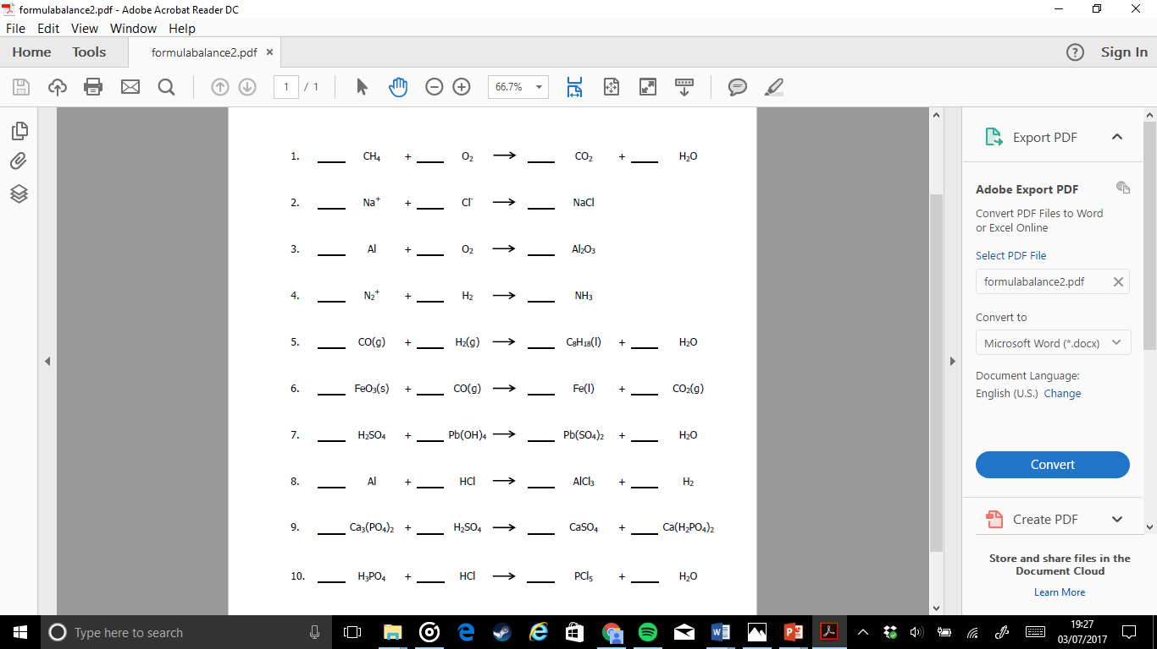

**Need help? Visit:**

[http://www.wikihow.com/Balance-Chemical-Equationsmulamass](https://tinyurl.com/relativeformulamass)

**Or use the QR code adjacent.**

Focus 6- The periodic table. Label all groups and periods with their names and indicate the reactivity.



**Need help? Visit:**

<http://www.bbc.co.uk/schools/gcsebitesize/science/triple_aqa/periodic_table/trends_periodic_table/revision/1/>

**Or use the QR code adjacent.**